**Internship Report**

Submit in partial fulfilment of the requirements for the award of degree of

**“Master of Computer Application”**

**(MCA)**

**Specialization – Web Development**



**Submitted To**

LOVELY PROFESSIONAL UNIVERSITY,

PHAGWARA (PUNJAB)

**Submitted By:**

Name : - **Ekhlakh Ahmad**

Regi No.: - **12209166**

Company Name: - **Acacious Technologies**

Designation : - **Software Trainee Intern**

**Submitted To:**

Name : - **Dr. Manik Mehra**

ID No.: - **27377**

Designation : - **Professor, Lovely Professional University, Phagwara**

**Declaration by Supervisor**

This is to certify that **Ekhlakh Ahmad** Reg. No. **12209166** from Lovely Professional university, Phagwara (Punjab), has worked as an intern in **Software** **Trainee Intern** on **“Acacious Technologies, Noida, U.P”** under my supervision from **April ‘2024** to **Present**. It is further stated that the work carried out by the student is a record of original work to the best of my knowledge for the partial fulfilment of the requirements for the award of the degree, **Master of Computer Application (MCA).**

**Name of External Supervisor Name of Internal Supervisor**

Mr. Abhishek Kumar Singh Manik Mehra

(Sr. Software Developer) (Professor, SCA, LPU)

**Designation of the External Supervisor Designation of Internal Supervisor**

Senior Software Developer, Placement Mentor

**Declaration by Student**

I, **Ekhlakh Ahmad**, Reg No. **12209166**, hereby declare that the work done by me on **“Implementation of Web Application”** from **April ‘2024 to Present**, under the supervision of **Mr. Abhishek Kumar Singh**, Senior Software Developer, **Acacious Technologies, Noida, U.P** and **Manik Mehra, Placement Mentor**, **Lovely Professional University, Phagwara (Punjab)** is a record of original work for the partial fulfilment of the requirements for the word of the degree, **Master in Computer Applications (MCA).**

Name: - **Ekhlakh Ahmad**

Reg. No.: - **12209166**

**ACKNOWLEDGEMENT**

The OJT opportunity I had with Acacious Technologies was a great chance for learning and professional development. Therefore, I consider myself as a very lucky individual as I was provided with an opportunity to be a part of it. I am also grateful for having a chance to meet so many wonderful people and professionals who led me though this internship period.

Bearing in mind previous I am using this opportunity to express my deepest gratitude and special thanks to the **Mr. Abhishek Kumar Singh, Sr. Software Developer**, who despite being extraordinary busy with his duties, took time out to hear, guide and keep me on the correct path and allowing me to carry out my project at their esteemed organization and extending during the training.

I express my deepest thanks to **Mr. Sarabjit Kumar (Placement Co-Ordinator)**, Ass. Professor, LPU for taking part in useful decision & giving necessary and guidance and arranged all facilities to make life easier. I choose this moment to acknowledge his contribution gratefully.

Name: - Ekhlakh Ahmad

Reg. No.: - 12209166

**Undertaking By the Student for OJT Certificate**

Undertaking by the student for submitting Final Certificate of Six-Months OJT

Student Name : - Ekhlakh Ahmad

Registration No. : - 12209166

Program Name : - MCA

Batch Year : - 2022 – 2024

Course Code : - CAP – 841

Mobile No. : - +91 9576650491

I understand that I have been provisionally allowed to appeal for the ETP viva and I hereby declare that since I am on Six months OJT, thus I shall submit my final certificate of Full-Term Internship/OJT to university after completion of my Internship/OJT but not later than 31st July 2024. I am aware that in case, I am unable to submit the same till the above-mentioned date, my final evaluation of Internship/OJT shall be discarded by the university, and I grade shall be awarded in the result.

Signature of Student Signature of TPC-School Signature of HOS

**__________________ ______________________ ________________**

**Table of Contents**

|  |  |  |
| --- | --- | --- |
| Sl. No. | Title | Page No. |
| 1 | Declaration by Supervisor | 2 |
| 2 | Declaration by Student | 3 |
| 3 | ACKNOWLEDGEMENT | 4 |
| 4 | Undertaking By the Student for OJT Certificate | 5 |
| 5 | Introduction of the Company | 7-8 |
| 6 | Project Report | 9 |
| 7 | Learning Duration OJT | 10-12 |
| 8 | Annexure-XIII (To be brought at ETP Viva only) | 13 |
| 9 | Annexure – XII- External Supervisor Details Performance | 14 |
| 10 | Salary Slip | 15-16 |
| 11 | Offer Later | 17-19 |

**Introduction of the Company**



**About Acacious Technologies**

**We are registered firm with the GST number 09ARLPK5997N1ZM**

We are one of the leading service providers for Search Engine Optimisation. We have over a million clients in our customer database who have indulged in receiving SEO services from us. This has not only blessed our SEO team with flourishing in their respective expertise but also to generate innumerable feedback to upgrade our scope of implications. We have tried our best to quote our clients in the most affordable rates possible. Client satisfaction has always been our sole objective because we believe that priorities cannot be ignored!

**How do we work?**

We have a dedicated team to attain our clients at any time of the day. Along with 24*7 client support, we provide maximum optimisation of client website for top search engine ranking. The sole objective is to ignite visibility and to boost the same with equal efficiency. We take care of organic visibility, quality traffic and sales of your online business. We have hit the target more times than we can keep a count on as far as your website traffic and visibility are concerned. We work hand-in-hand with our clients on their roads to glory, and we do take pride in it.

* Our Company is a solid Technology foundation.
* Team of 5 years of expert Technical Professionals.
* Client satisfaction is our first priority.
* 24*7 customer support is available.
* Work on smooth flywheel methodology
* Seamless communication with clients

Web Design and Development Service in India, and other countries help you to grow your business in a unique way. We strive hard to develop the finest IT solutions that will let you interact with your customers and mark your presence everywhere. We render pixel-perfect web designs that help you build your brand. Working on the motto that a website is not something that just ends up with .com or .in, but it should ultimately bring success to you, we cater to your entire requirements of web design, web development, mobile application development, and digital marketing too. So, if you want to design and develop a website that is fused with creativity, discuss your project idea with us!

Being a leading IT Company in India, Acacious Technologies delivers innovative solutions to clients all around the world. Our company collaborates with different technology partners to serve our customers with exactly they need! We work on the objective to render value-adding solutions to our valuable clients on a global basis.

**Why work with Acacious Technologies?**

We have been working in the market of Search Engine Optimisation for more than a decade, and we have set up the prestige of our own. We take pride in dealing straight with our clients. We have empathised with our clients through every thick and thin and have tried to be the stepping stones of their glory. We have worked for small, mid-sized as well as large organisations and have recorded each of their feedback. We try the most to deliver the work first. We guarantee excellent visibility and quality support in no time. We are a registered SEO company with a bright portfolio.

**Affordable Price quotes**

We believe that all small and large businesses have their own requirements and expectations to meet certain customer base. We offer multifarious packages with extended offers so that our clients possess the authority to choose the best for them. We do not limit our services to money. We never fall back in case our clients demand any extra assistance. We are confident that our biddings will never exceed any average SEO service provider in the nation; however, that will never mean a compromise of quality to us. Offering good quality service at competitive rates has been our motto since the start, and we are lucky to uphold the reputation till date.

**Project Report**

I am not allowed to mention project or client details due to the “Code of Conduct” signed with the company, I am unable to share any specific information or details of the project in the report.

This report provides a comprehensive overview of a recent project undertaken by our team. Due to the “Code of Conduct” agreement signed with the company, specific details about the project, client, or related data cannot be disclosed. However, this document will outline the general structure, process, methodologies, and lessons learned throughout the project life cycle.

**Project Scope and Objectives:**

The project was initiated to address specific business needs within a defined scope. The primary objective was to deliver a solution that meets the client’s requirements while adhering to the company’s standards for quality and efficiency. While the details of these objectives are confidential, it can be stated that the project aimed to achieve significant improvements in operational performance and client satisfaction.

**Methodology and Approach:**

The project was executed using a hybrid methodology, integrating both agile and traditional project management principles. This approach allowed for flexibility in response to changing requirements, while still maintaining a structured framework for deliverables and timelines.

* Planning and Initiation: Establishing project goals, identifying key stakeholders, and developing a project plan.
* Design and Development: Crafting the solution architecture and building the necessary components to meet project objectives.
* Testing and Quality Assurance: Rigorous testing was conducted to ensure that solution met all functional requirements and none-functional requirements.
* Implementation and Development: The solution was rolled out in phases to ensure smooth integration with existing system.

**Outcomes and Deliverables:**

While the specific of the deliverables cannot be disclosed, the project successfully achieves its intended outcomes. The team was able to deliver a high-quality solution that met the client’s needs within the agreed-upon timeline and budget. The success of the project was measured using predefined metrics related to performance, efficiency, and client satisfaction.

**Learning Duration OJT**

I started my job in “Acacious Technologies” as a software developer Intern- Full Time at the time of my training period, I learned these technical skills.

**Technical Skills:**

* Learning React JS for Frontend development.
* Learning different tools to call API and run in local.
* Experience in using GIT for maintaining project histories, reverting changes, and ensuring code integrity in multiple-developer environments.
* API development for the Real Time web Application.
* Experience with MongoDB, getting data from frontend and saving that in database and fetching the data from database.
* Adapting the domain and learning the application how to debug inside the application.

**HTML (HyperText Markup Language):** HTML is the standard markup language used to create the structure and content of web pages. It defines elements like headings, paragraphs, links, images, and forms, forming the backbone of a website.

**CSS (Cascading Style Sheets):** CSS is used to style and layout web pages. It controls the visual appearance of HTML elements, such as colors, fonts, spacing, and positioning, enabling developers to create visually appealing and responsive websites.

**JavaScript (JS):** JavaScript is a programming language used to create interactive and dynamic content on websites. It allows developers to implement features like animations, form validations, and user interactions, enhancing the user experience.

**React:** React is a popular JavaScript library for building user interfaces, particularly single-page applications. It allows developers to create reusable UI components, manage state efficiently, and build complex user interfaces with ease.

**VS Code (Visual Studio Code):** VS Code is a powerful and widely-used code editor developed by Microsoft. It supports various programming languages, offers extensive extensions, and provides features like debugging, code completion, and Git integration.

**Online Compiler:** An online compiler is a web-based tool that allows users to write, compile, and execute code in various programming languages directly in the browser. It's useful for quick testing and development without needing to install a local development environment.

**Browser:** A browser is a software application used to access and view websites on the internet. Popular browsers include Google Chrome, Mozilla Firefox, Microsoft Edge, and Safari. Browsers interpret HTML, CSS, and JavaScript to render web pages.

**Git:** Git is a distributed version control system used to track changes in source code during software development. It enables multiple developers to collaborate on a project, manage code versions, and revert to previous states if needed.

**GitHub:** GitHub is a web-based platform that hosts Git repositories. It provides tools for version control, collaboration, issue tracking, and project management, making it easier for developers to work together on code and share projects.

**Responsive Website:** A responsive website is designed to adapt to different screen sizes and devices, ensuring a consistent and user-friendly experience across desktops, tablets, and smartphones. This is achieved using flexible layouts, media queries, and other CSS techniques.

**Hosting:** Hosting refers to the service of storing and serving website files on a server, making them accessible to users on the internet. Web hosting providers offer various hosting plans, such as shared, VPS, and dedicated hosting, depending on the website's needs.

**Firebase:** Firebase is a platform developed by Google that provides a suite of tools for building mobile and web applications. It includes features like real-time databases, authentication, hosting, and cloud functions, making it popular for rapid app development.

**AWS (Amazon Web Services):** AWS is a comprehensive cloud computing platform provided by Amazon. It offers a wide range of services, including computing power, storage, databases, and machine learning, enabling businesses to build and scale applications in the cloud.

**SQL:** SQL (Structured Query Language) is a standard language used to manage and manipulate relational databases. It allows developers to perform operations like querying, updating, and managing database records. Common SQL databases include MySQL, PostgreSQL, and SQLite.

**RESTful API:** A RESTful API (Representational State Transfer) is an architectural style for designing networked applications. It relies on stateless communication and standard HTTP methods (GET, POST, PUT, DELETE) to interact with resources, making it a popular choice for web services.

**PHP:** PHP is a server-side scripting language widely used for web development. It's known for being easy to learn and is the foundation of many content management systems (CMS) like WordPress.

**Node.js:** Node.js is a runtime environment that allows developers to execute JavaScript code on the server side. It's built on Chrome's V8 JavaScript engine and is commonly used for building fast and scalable web applications. Node.js is popular for its non-blocking, event-driven architecture.

**Express.js:** Express.js is a minimalist web framework for Node.js, used for building web applications and APIs. It simplifies the process of handling HTTP requests, routing, and middleware, making it easier to create robust and scalable backend services.

**Annexure-XIII (To be brought at ETP Viva only)**

**Continuous Assessment (CA) for Internship/OJT**

(By external supervisor from organization)

Name of the Student **___Ekhlakh Ahmad­­­______** Registration Number **__12209166_____**

Internship Project Title (if/any): **AT/02/24/19/IN_______________________________________**

Name of Organization & Address: **Acacious Technologies H- 1A/20, H Block, Sector 63, Noida, Uttar Pradesh 201301. ________________________________________________________**

**__________________________________________________________________________________________________**

Name of External Internship in charge (with mobile number): **___________________________**

**Mr. Abhishek Kumar Singh**. Contact No.: **9711229767_________________________________**

|  |  |  |  |
| --- | --- | --- | --- |
| **Sl. No.** | **Criteria** | **Marks Obtained** | **Maximum Marks** |
| 1. | Student conduct during Internship | 7 | 10 |
| 2. | Punctuality and Enthusiasm | 17 | 20 |
| 3. | Technical Skill & Knowledge | 19 | 20 |
| 4. | Performance | 47 | 50 |
| 5. | **Total** | **90** | **100** |

Date: **1st August ______** Authorized Signature: **Arti Shrivastava__**

Name: **Arti Shrivastava** **___** Designation: **HR & Admin__________**

Company Seal:

**Annexure – XII**

**External Supervisor Details Performance**

**Part A –**

**Student Details:**

Student Name: _______Ekhlakh Ahmad___________

Registration No.: _______12209166__________________

Batch Year: _______2022 – 24___________________

Contact Number: _______+91 9576650491___________

Email ID: _______ekhlakhahmad95@gmail.com___________

**Part B –**

**Supervisor Details:**

Name of Supervisor: _______Mr. Abhishek Kumar Singh_________

Designation of supervisor.: _______Sr. Software Developer______

Name of organization: _______Acacious Technologies______

Contact Number: _______+91 9711229767___________



Date: __01/08/2024___

**Salary Slip**

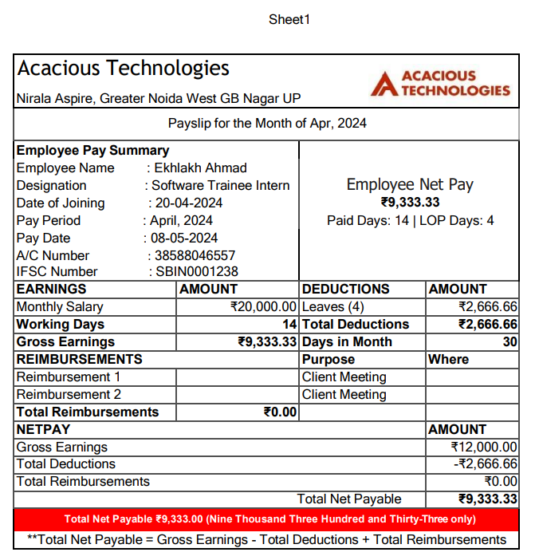

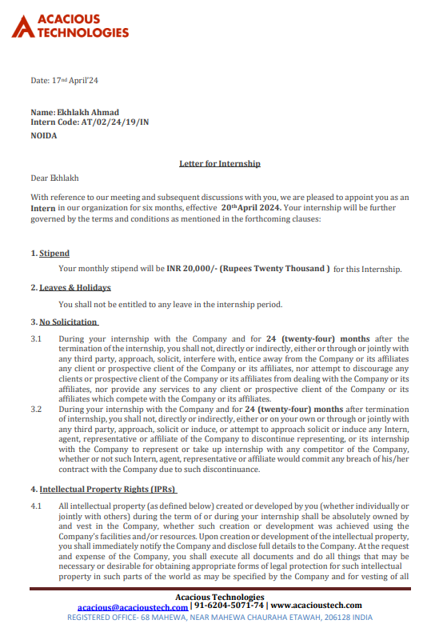**Offer Later**

